|  |  |
| --- | --- |
|  |  |

|  |
| --- |
| User Guide: KPI-Based Route Map  (Power BI custom visual) |
|  |

# Short Description

## A KPI-based interactive route map, showing the origins, destinations, and routes of the carrier (airplanes, cargo/cruise ships, etc.)

# Overview

An advanced route map, which not only provides the route between multiple locations, but also provides the facility to highlight routes based on certain KPIs. Often used by airlines to simulate flight path, find the optimized air route, or gauge the performance of various flight routes, this visual allows you to interact with various locations on a map to view flights to and from that location. It also allows the user to view detailed information about a flight route, such as the name of the airline, target visitors, revenue generated by that flight, and target revenue of that flight. It can be used for other modes of transportation as well, such as cargo or cruise ships. Google map API is used to render the map in the visual.

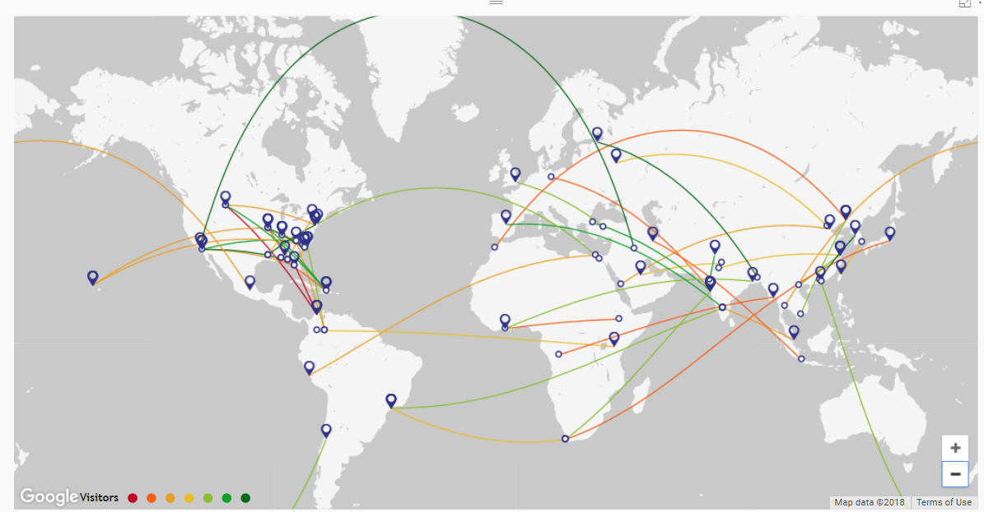

Features of KPI based Route Map:

1. KPI value-based map route highlight with 7 color gradients
2. Individual route highlight on-click of route
3. Data slice on-click of route
4. Route filter on-click of location (origin/destination)
5. Tooltip with the ability to showcase multiple KPI datapoints
6. Availability of 5 map variations
7. Ability to stage the map in visual by giving center coordinates
8. Tooltip enabled route and ‘Origin’, ‘Destination’ icons
9. Configurable path color and path display setting (solid/dash)
10. Animated path visualization for simulating flight/ship track
11. Customized Google map with cleaner version without city names and boundary lines

# Required Data Fields:

1. **Origin Latitude*:** This field will consist of latitude coordinates for all origin locations.
2. **Origin Longitude*:** This field will consist of longitude coordinates for all origin locations.
3. **Destination Latitude*:** This field will consist of latitude coordinates for all destination locations.
4. **Destination Longitude*:** This field will consist of longitude coordinates for all destination locations.
5. **Transportation Detail:** This field will consist of details for all routes, such as airline name, visitor count, etc.
6. **Transport Type**: This data field takes the input of flight/ship type. For example, whether a flight is domestic or international.
7. **Tooltips**: Consists of all information that will be shown in a tooltip when we hover over a route or location.
8. **KPI**\*: This field will consist of a defined value, which the user can use to gauge the route performance.

Note: All fields marked with the asterisk (*) are mandatory. Without it, the route will not appear on the map.

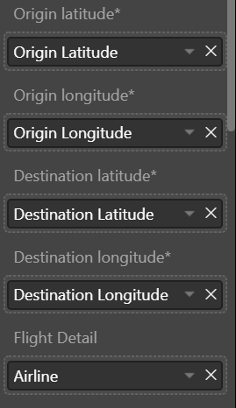 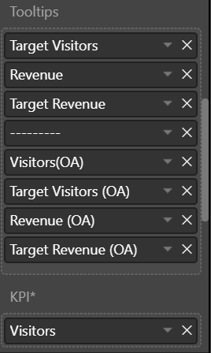

# Formatting Pane settings:

1. **Legend**: Based on the KPI performance of route, a color gradient will be applied—usually ranging from red to green. This field is used to define the thresholds for color allocation.

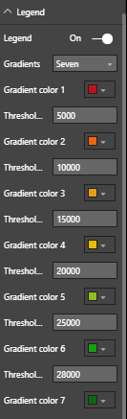

1. **Path**: If applicable, differentiate between domestic and international routes by viewing them as a dotted or solid line.

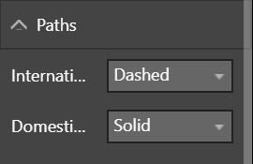

# Use Cases

* **Route performance review based on KPI**

The map visual allows us to highlight routes based on a chosen KPI value, applying a color gradient that is defined by various KPI value ranges.

For example, as soon as we select the **Visitors** datain the value field**,** the visual will adjust route color according to the number of visitors.

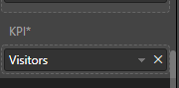

A performance comparison can be done between routes based on a color gradient, usually ranging from red to green. However, users can select the color(s) of their choice to distinguish between different KPI value ranges. At any given time, a minimum of 2 or a maximum of 7 colors can be allocated to routes.

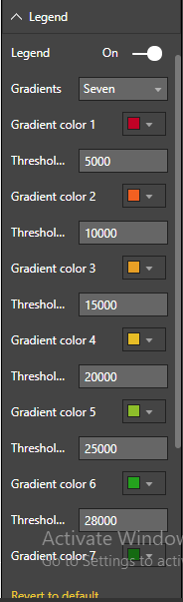

Colors will be allocated based on the number of values provided for KPI data. Accordingly, that many colors will be displayed in the legend. In this example, we have created 7 ranges for the ‘visitor’ KPI, and as a result, 7 colors are displayed in the legend.



So, based on **‘visitor’** as a KPI value, each of the routes are highlighted in colors that correspond with the number of visitors per flight. In the screenshot below, we can see the flight routes and their respective colors, which are based on their KPI data. The user can also click on origin or destination icons to check the cities connected through these routes.



To focus on low, medium, or high performing routes, the user can click on the legend to view all routes belonging to the selected threshold. For example, in the screenshot below, orange has been selected from the legend to highlight flights with a visitor count between 5,000 to 10,000 people.

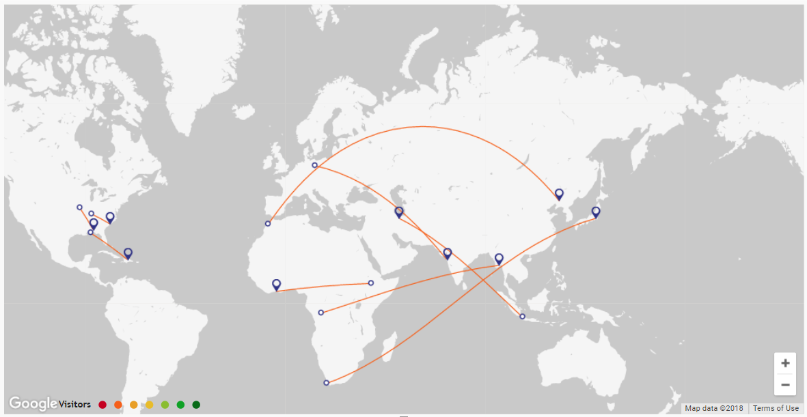

* **Route performance data comparison:**

We can also compare each flight's KPI data with the average performance of other airlines (defined in the screenshot below as "OA"). We can achieve this view by providing data value to the tooltip value in the data pane. Hover over a route to view detailed information of that route.

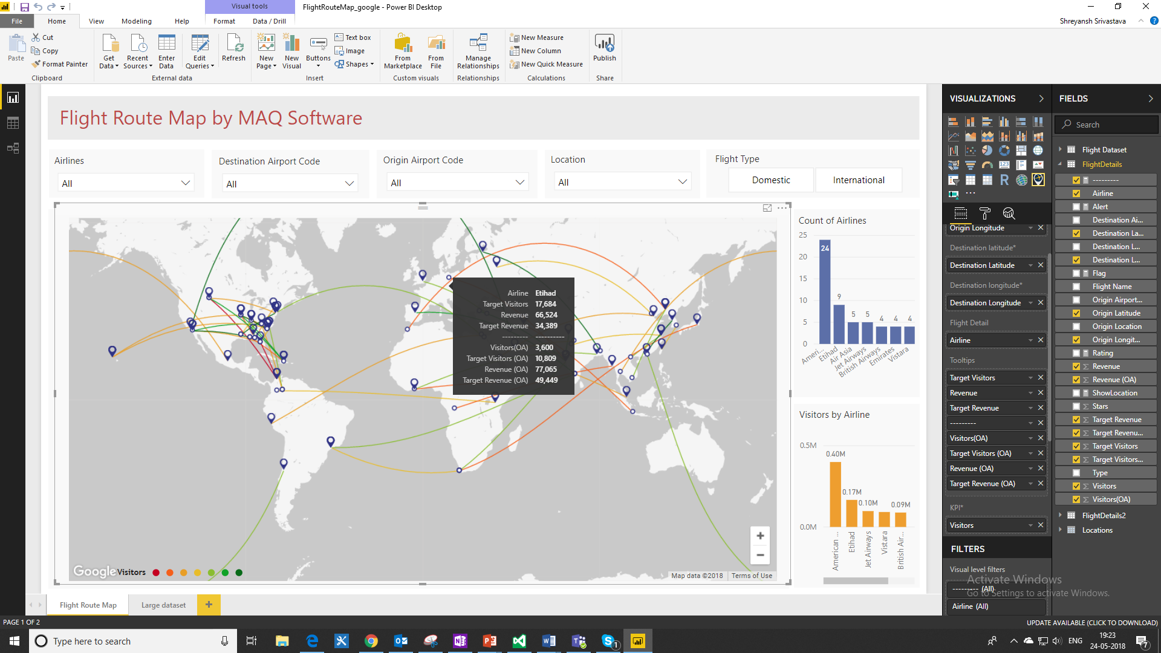

Clicking on a route will reduce the opacity of all the other routes, allowing you to clearly focus on the selected route. On-click of the route also helps in the slicing of data, in other data charts displaying related data. Hence, the visual is also interactive in nature.

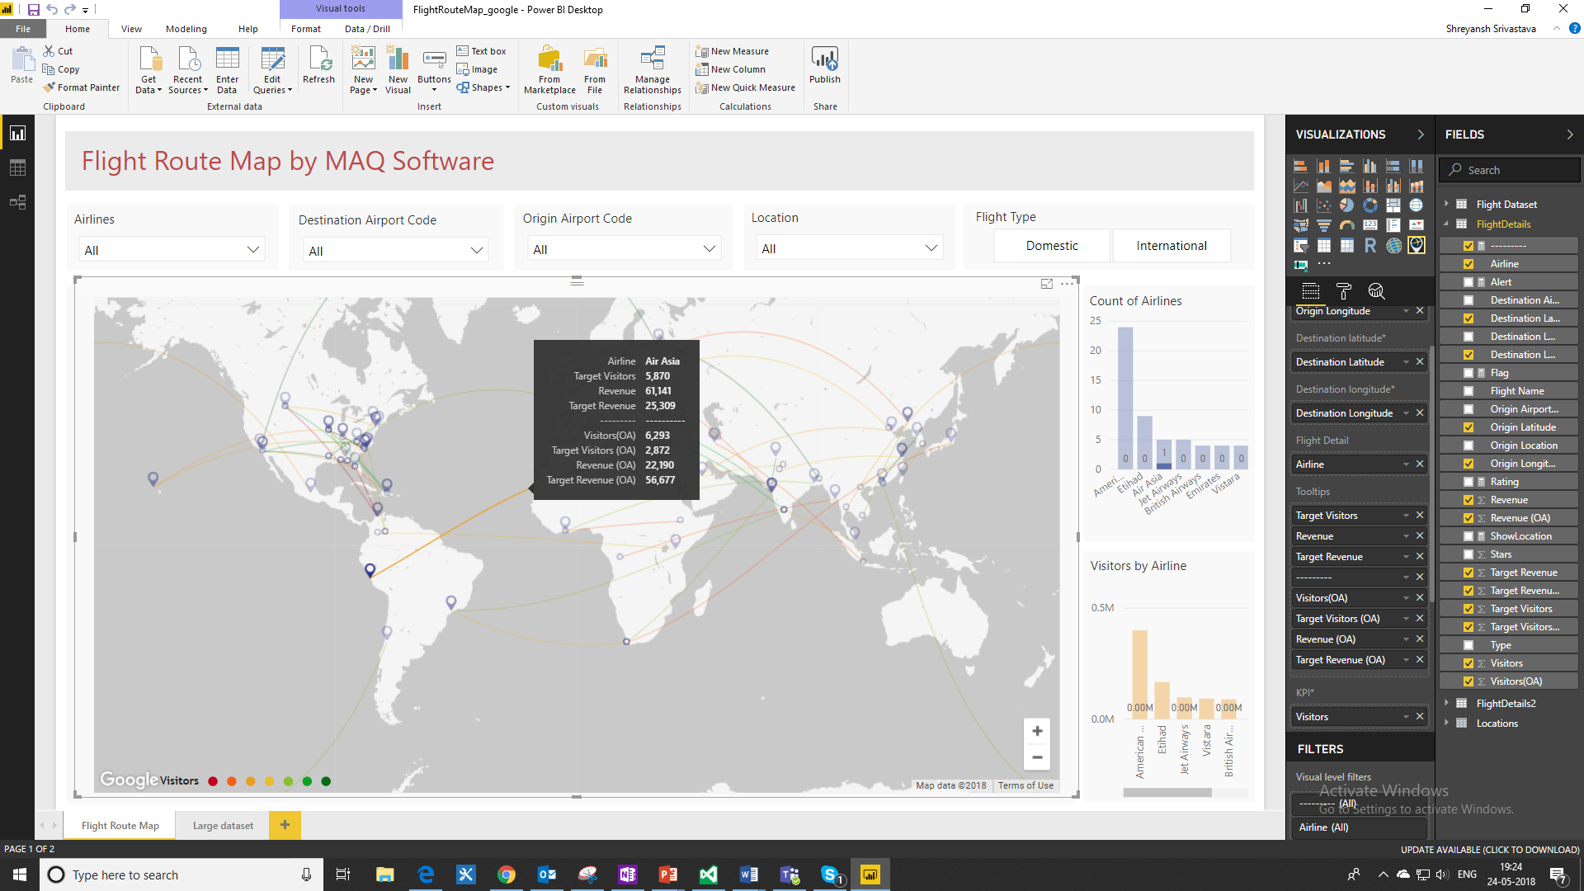

* **Dashed vs Solid lines for data depiction**

The map can also distinguish between domestic or international routes by representing them as either solid or dotted lines.

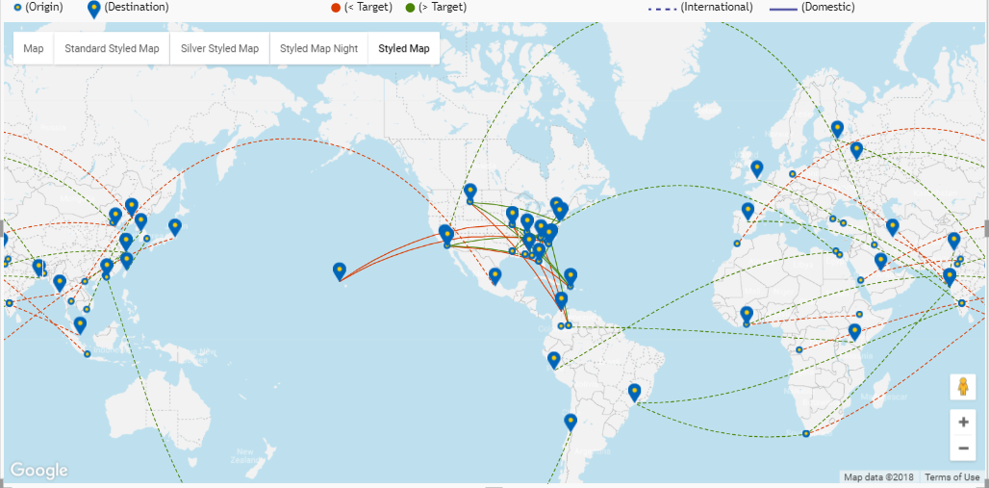

[Grab your reader’s attention with a great quote from the document or use this space to emphasize a key point. To place this text box anywhere on the page, just drag it.]

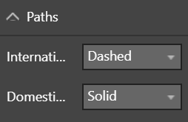

* **Location specific data highlight:** Clicking on a location will show all flights to or from that location. Therefore, the user can focus on data related to a location they are interested in.

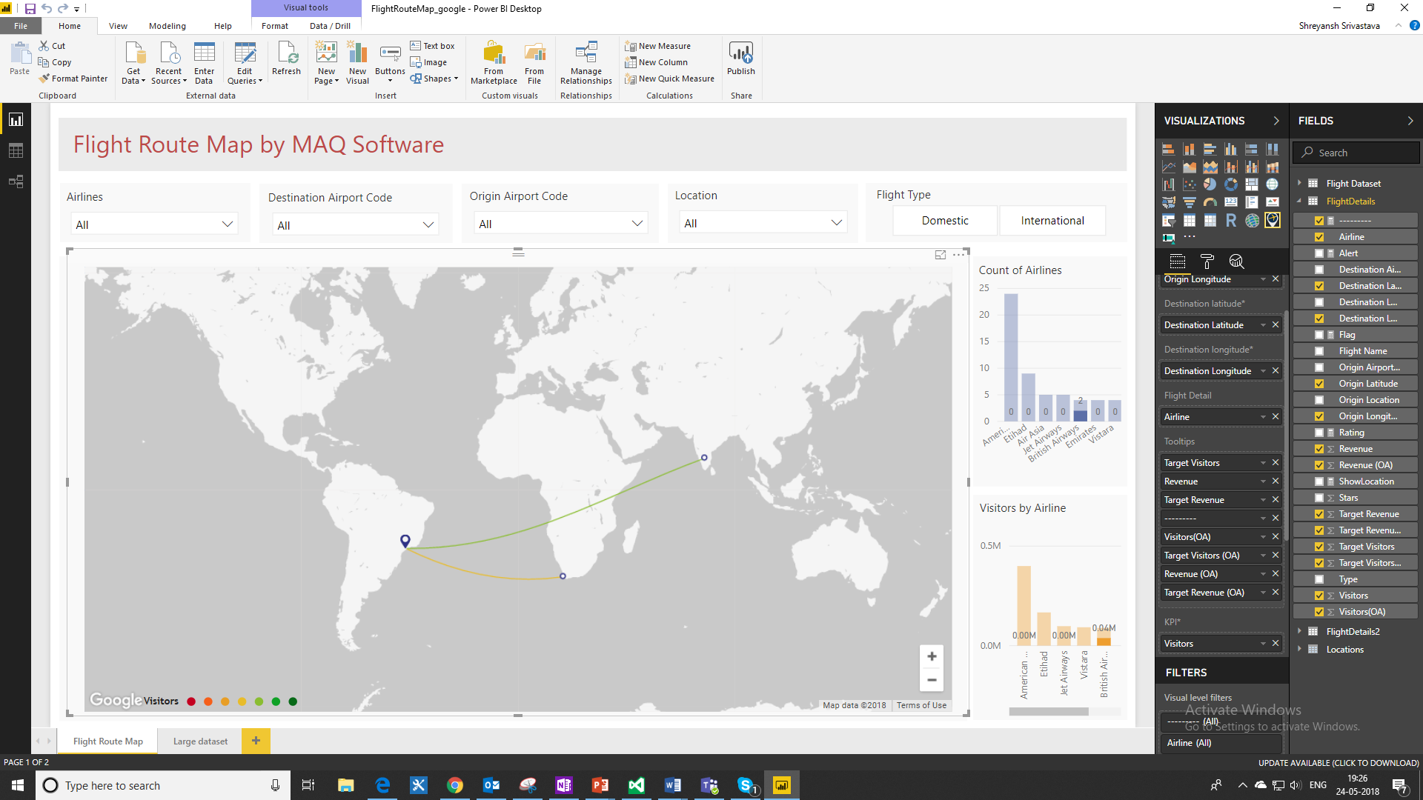

* **Zoom in, zoom out, or pan across the map.**

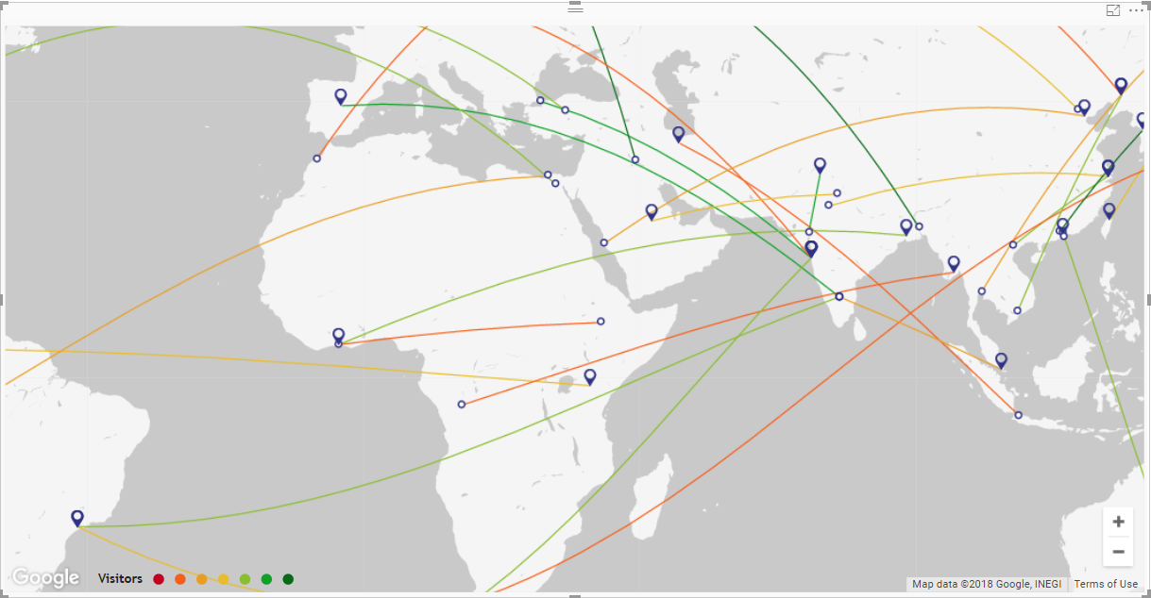

# Configuration Options:

* **API Key**

This key is required to fetch Google Maps and incorporate its properties into the visual. In the beginning, a prompt on the visual will ask for an API key, and the map won’t show until it is entered. A key can be generated [here](https://developers.google.com/maps/documentation/javascript/get-api-key) for users who want to use this visual. By adding this key, Google Maps will register the app on their API console.

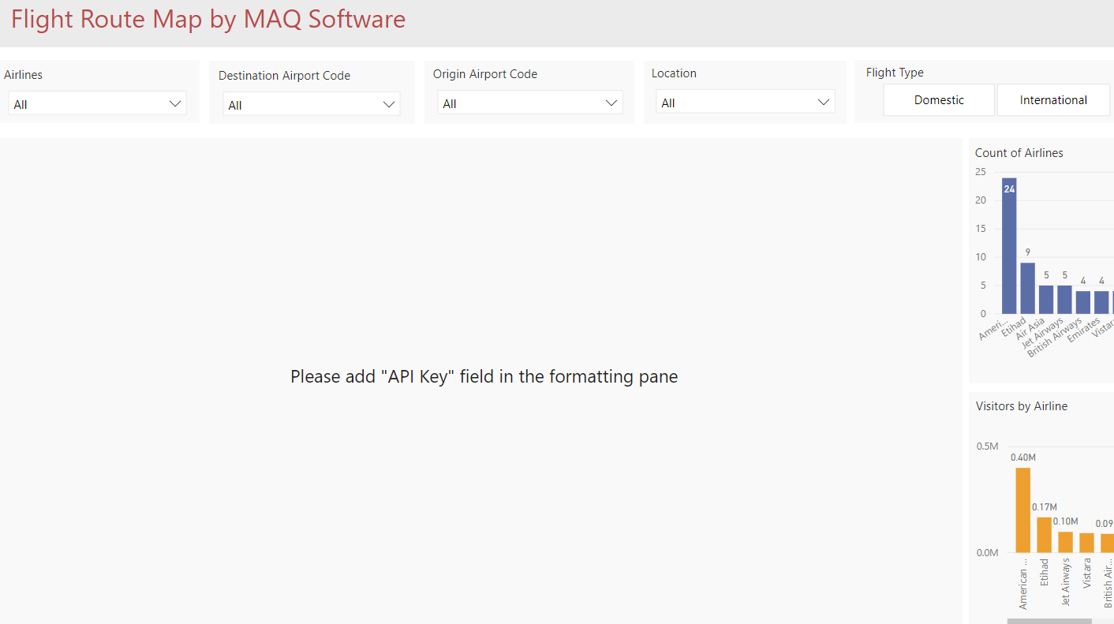

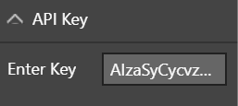

* **Map types**

Select from five different views for the map. Some examples are displayed in the screenshots below.

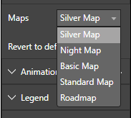

Examples:

Night Map:

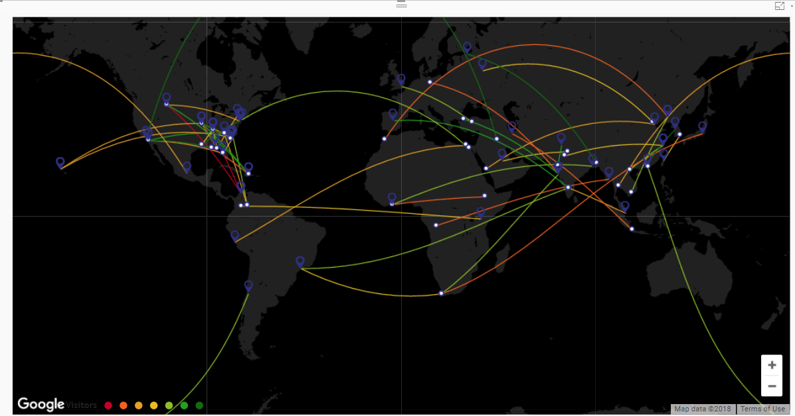

Road Map:

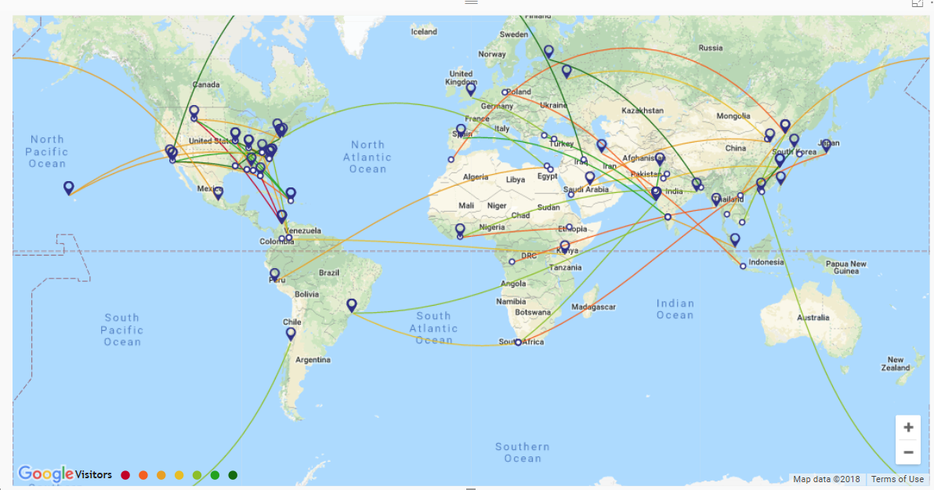

* **Animation**

Provides an animated view of flight movement from the origin to destination. The animation option can be toggled on/off, based on your preference.

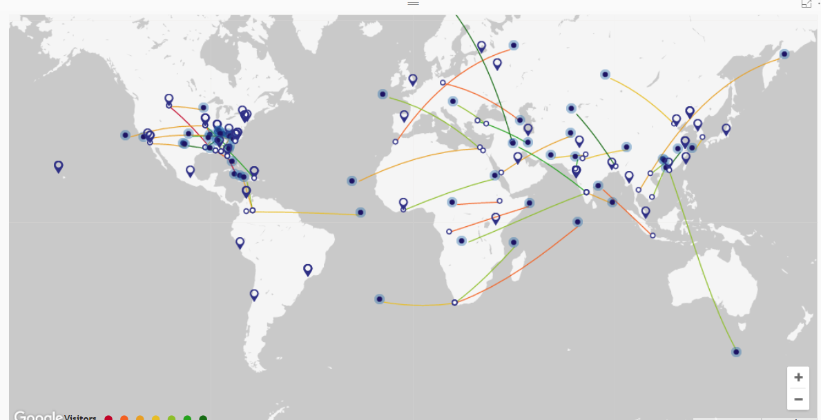

Visual Undergoing Animation



* **Central Coordinates**

Change the view of the map by providing latitude/longitude coordinates that will define the center of the map.

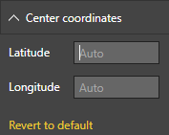

*Limitations:*

1. Power BI custom visual limitation of supporting 30k rows
2. Google Map license key requirement for commercial usage. Will support 25,000 hit/refresh without the license.